MODULE 1 EXAM

**CLOUD**

**Q1.** Ec2 instance

Step1: To create an instance first we have to go to the aws console. On the console either we can click on the search bar to search for EC2 or if we have already worked on ec2 we can see in the recently visited section also.

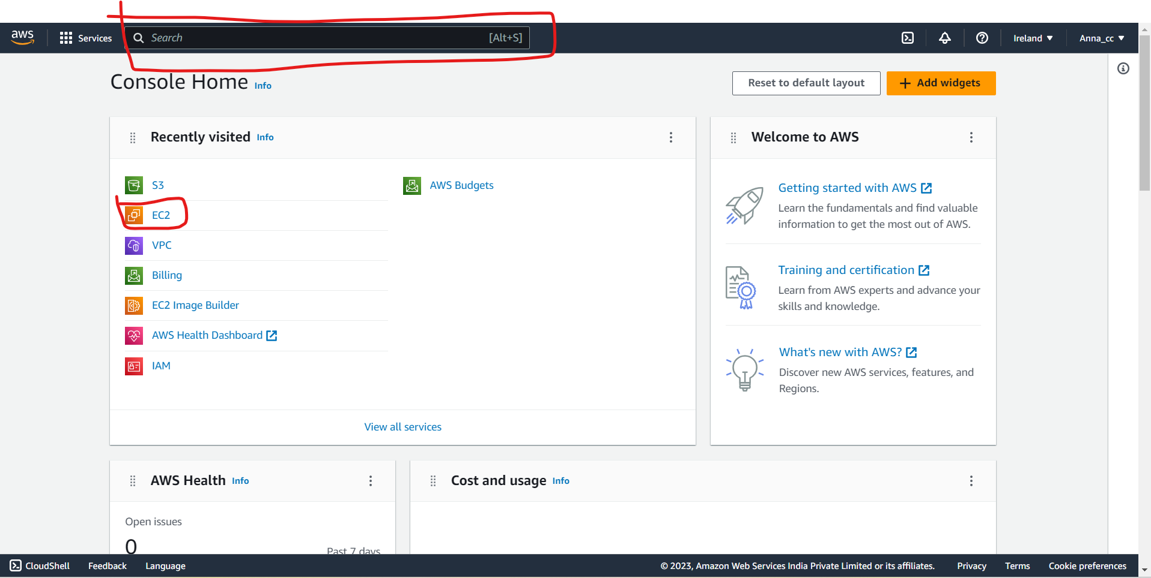

Step2: After coming to ec2 we can can either click on the Instances option showing in the Resources section or we can click on instances from the menu on the left side.

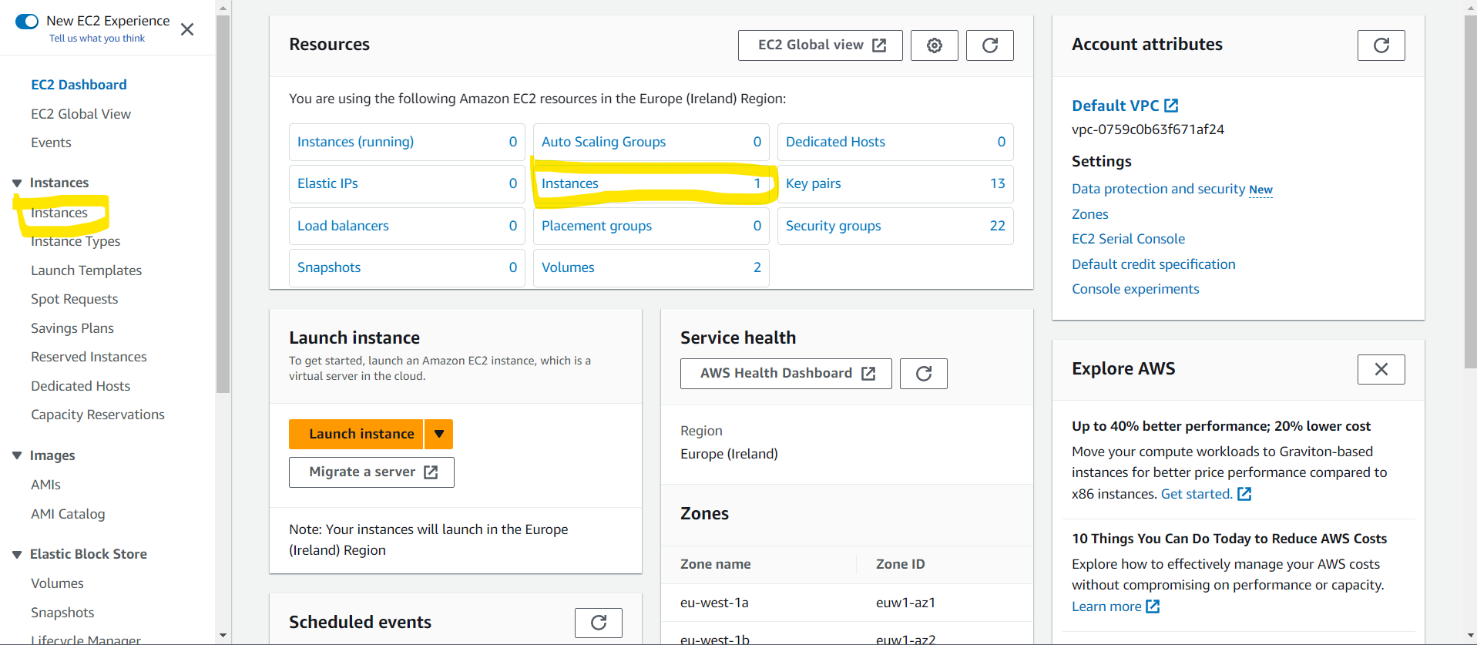

Step3: Now we have to click on create instance to move further in the process of making instances.

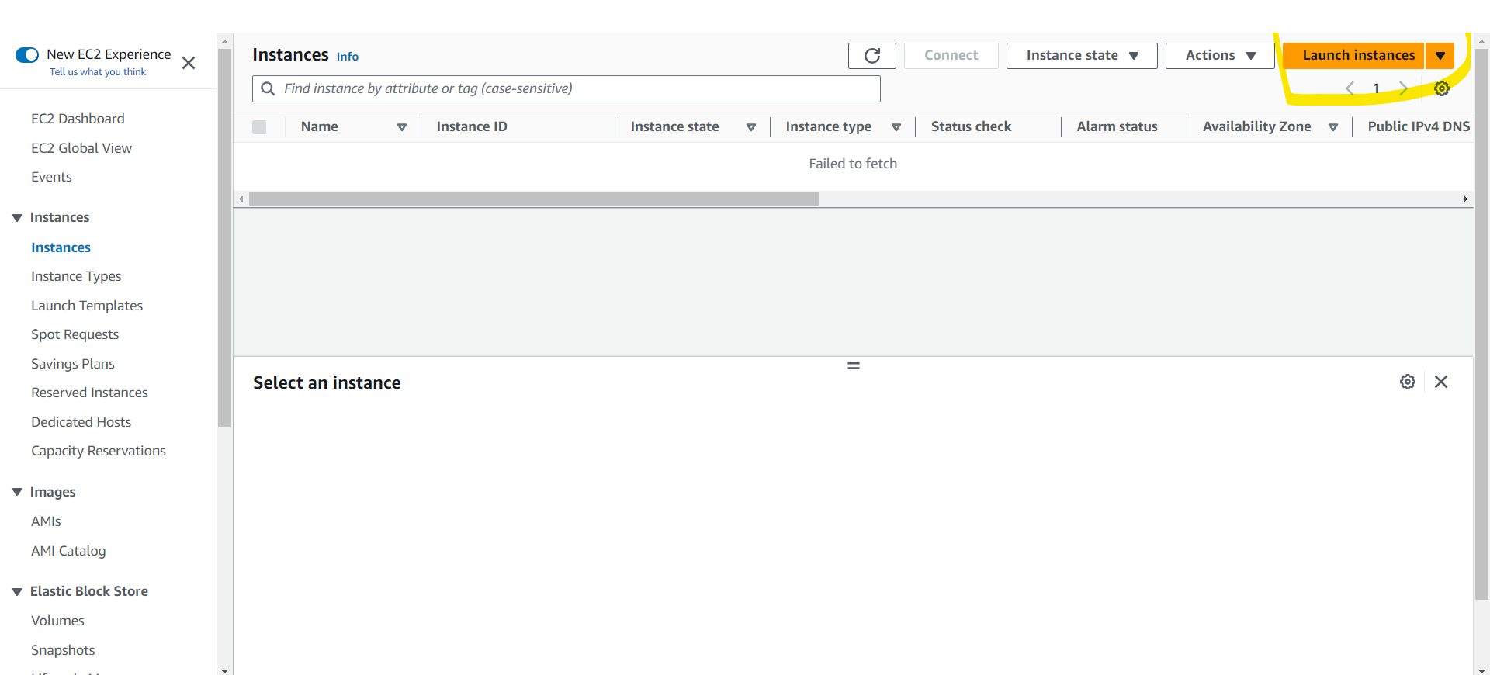

Step4 : The first step in making instances is naming them, we can name our instances as we like, here I am going to name my instance as “exami”

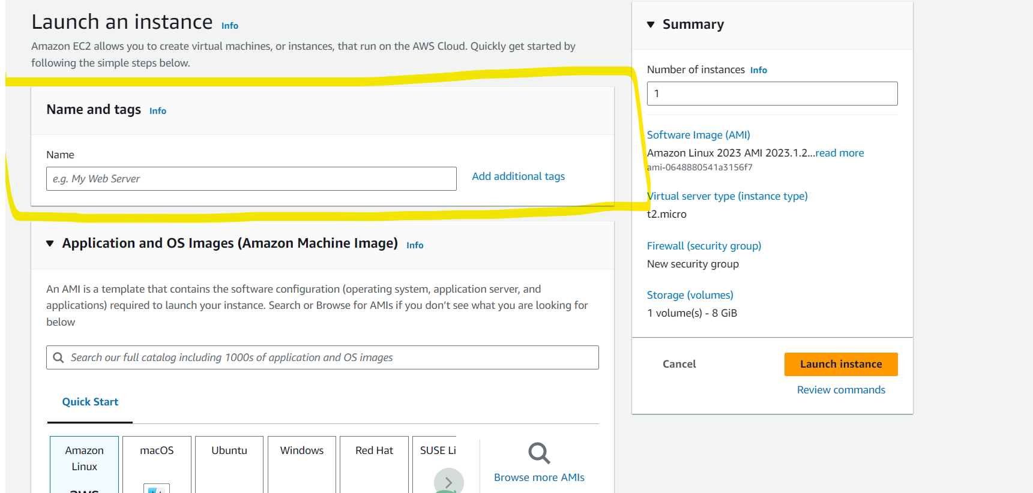

Step5: further moving with the making of instances we have to choose a os to work on, as we are working we are granted a free tier option to work with as to avoid the billing.

Going further we have to select an AMI (amazon machine image) whic also has several free tier options.

In the next step we’ll select the architecture for our ec2 instance.

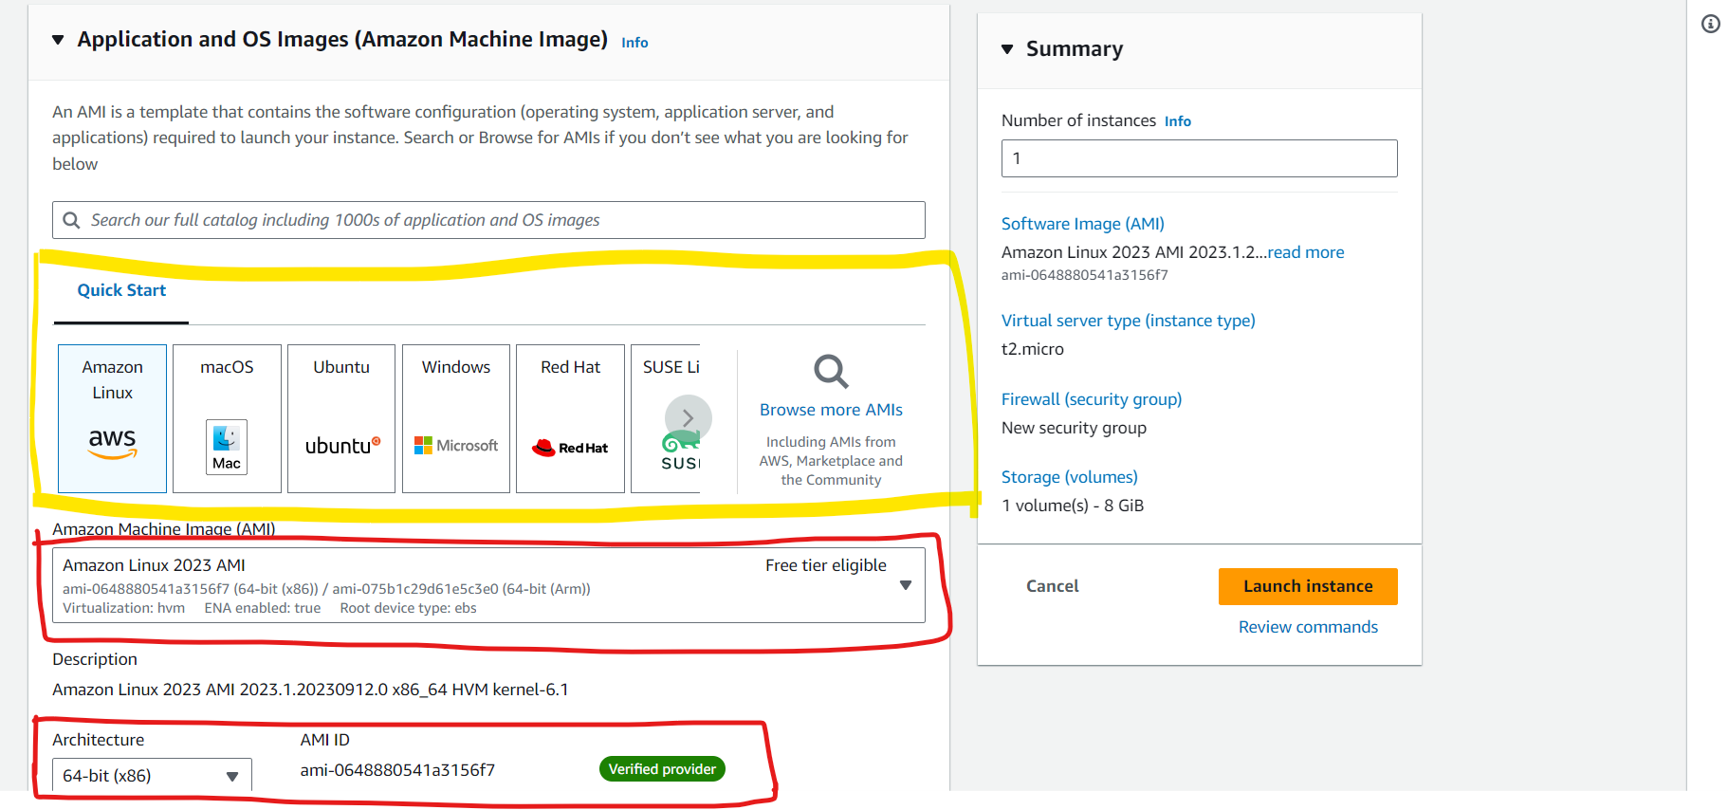

In these steps I have selected

OS : Amazon Linux (as it comes under the free tier)

AMI : Amazon Linux 2023 AMI

Architeture : as 64-bit (x86) (this also comes under free tier)

Step 6: Now we have to select an instance of a type under which we will be working. There are different options from frere tier to work on but here we are going further with “t2.micro” which comes under t-series.

Moving forward to work on ec2 we have to create a unique id which is called as keypair

For this instance I am going to name it as “examkey”

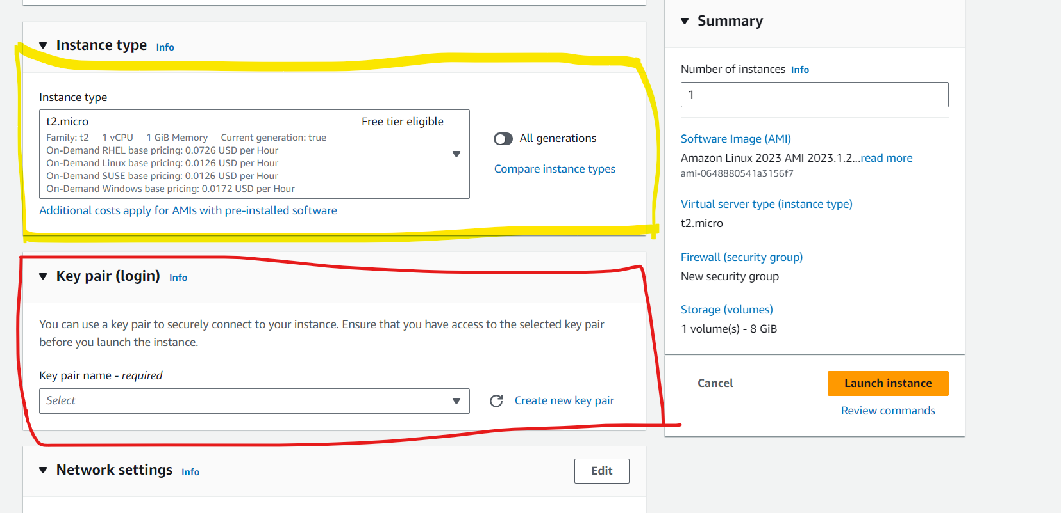

But for that the next step is giving the key a name, selecting its types and file format.

For file format we are going to select .ppk as we are working in putty.

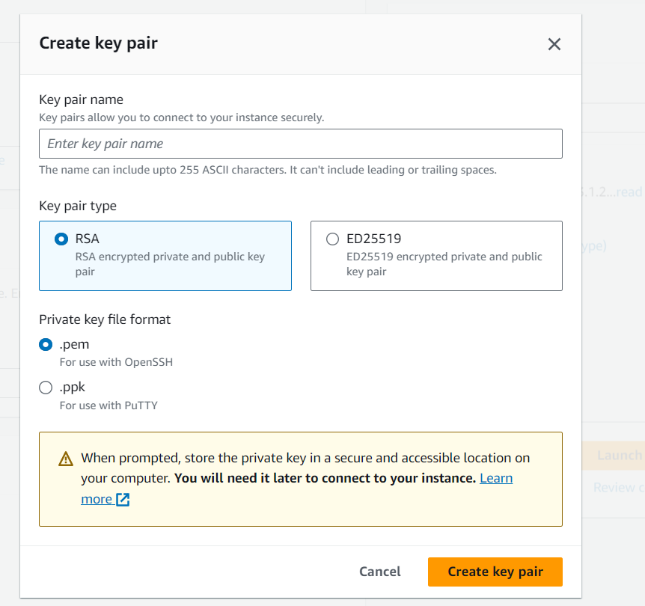

Step7: in the next step we have to select some network setting in which we have to allow the SSH, HTTPS and HTTP traffic as we are going to deploy a website further using this instance

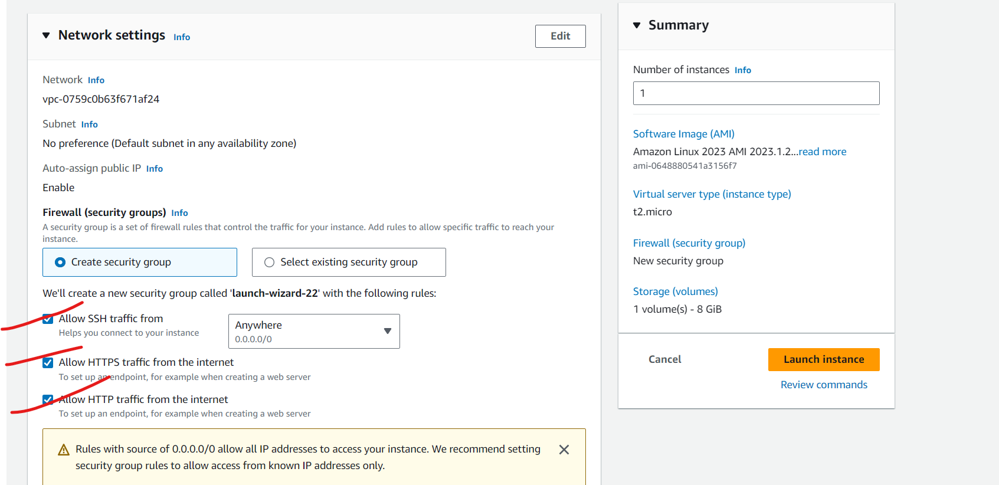

Step8: We have to now check the configuration and the Launch the instance.

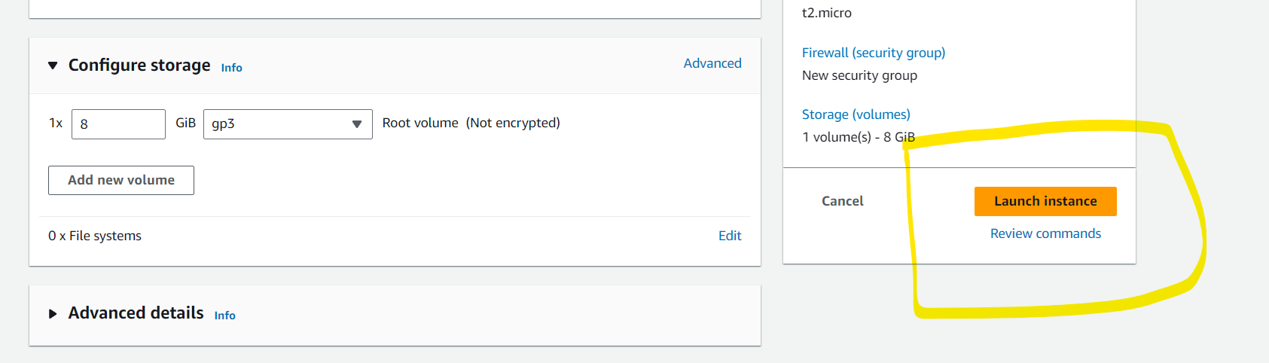

Step9 : again we have to visit the page where the instance list is shown and click on the instance id

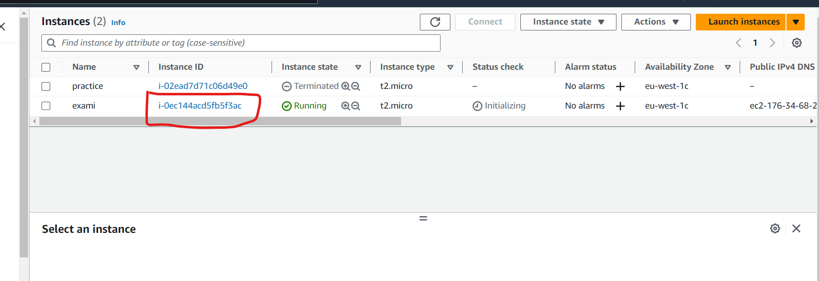

After going to the summary page we have to copy the public ip by which are going to open the putty

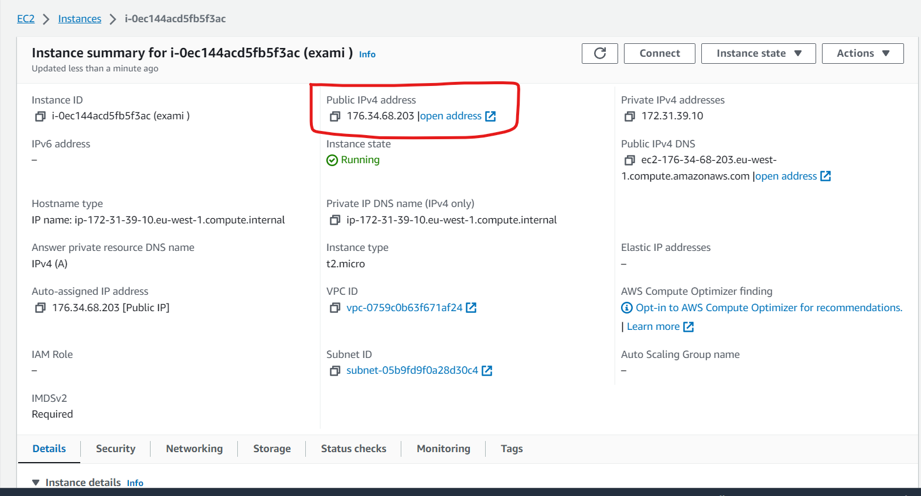

Step10: After opening putty the first thing we are going to do is give a host name

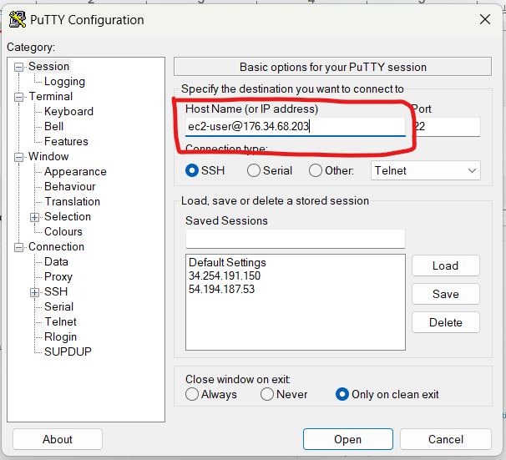

Then we are going to load the keypair we have downloaded earlier to putty to acces our instance.

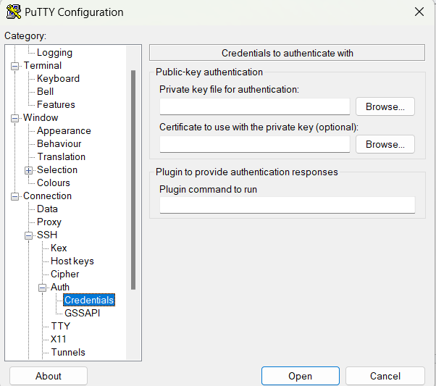

Step11: the first thing we are going to do after login in is to go to the root user by command “sudo -i”



Then we are going to update by command “yum update -y”

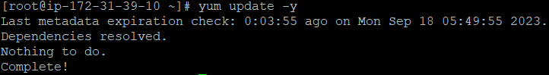

Movig further to launch the website we have to install httpd so we will use command

“yum install httpd -y”



After the installation was done we have to start the httpd, check if its working and the enable it to for the further use

To start : systemctl start httpd

To status: systemctl status httpd

To enable: systemctl enable httpd

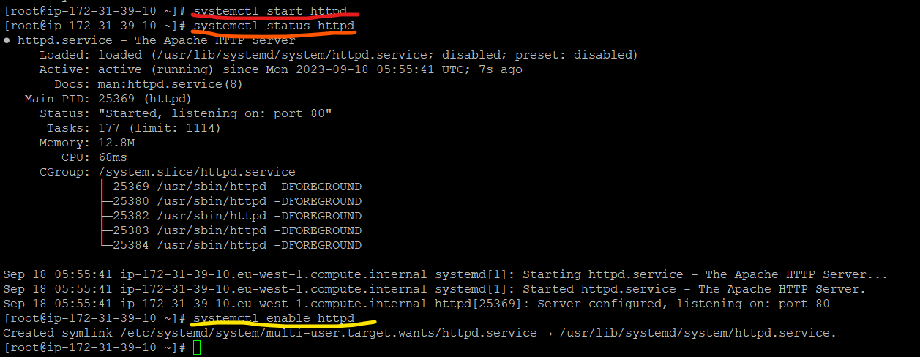

Step12: we then go to the html by using command

“cd /var/www/html”

After entering html we have to create a file their in which we are going to write the content we want on our website

To create a file command is “nano index.html”



After the creation and editing of the file is done we again have to copy the ip address and post it on the web browser to see the website.

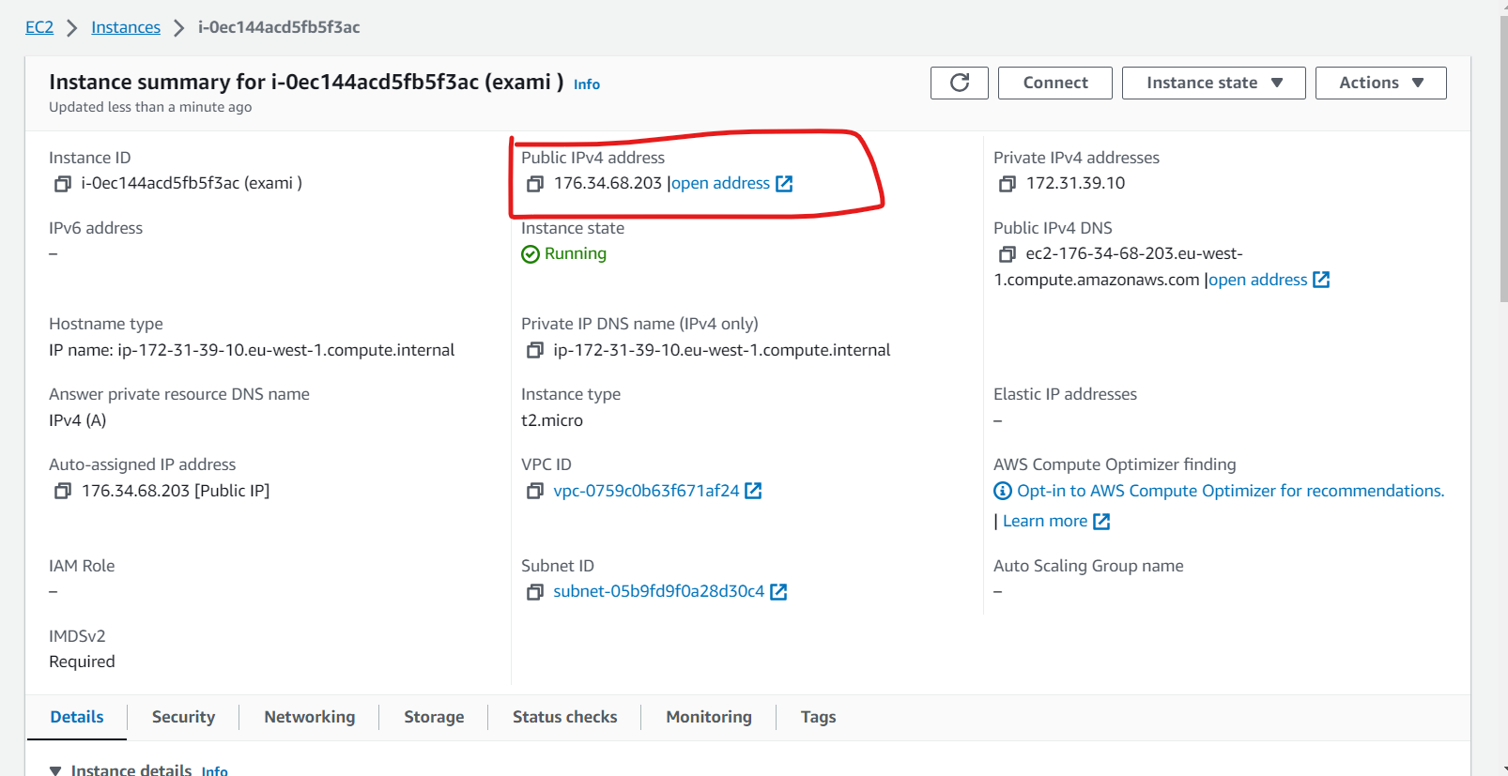

This page is the website which I've created

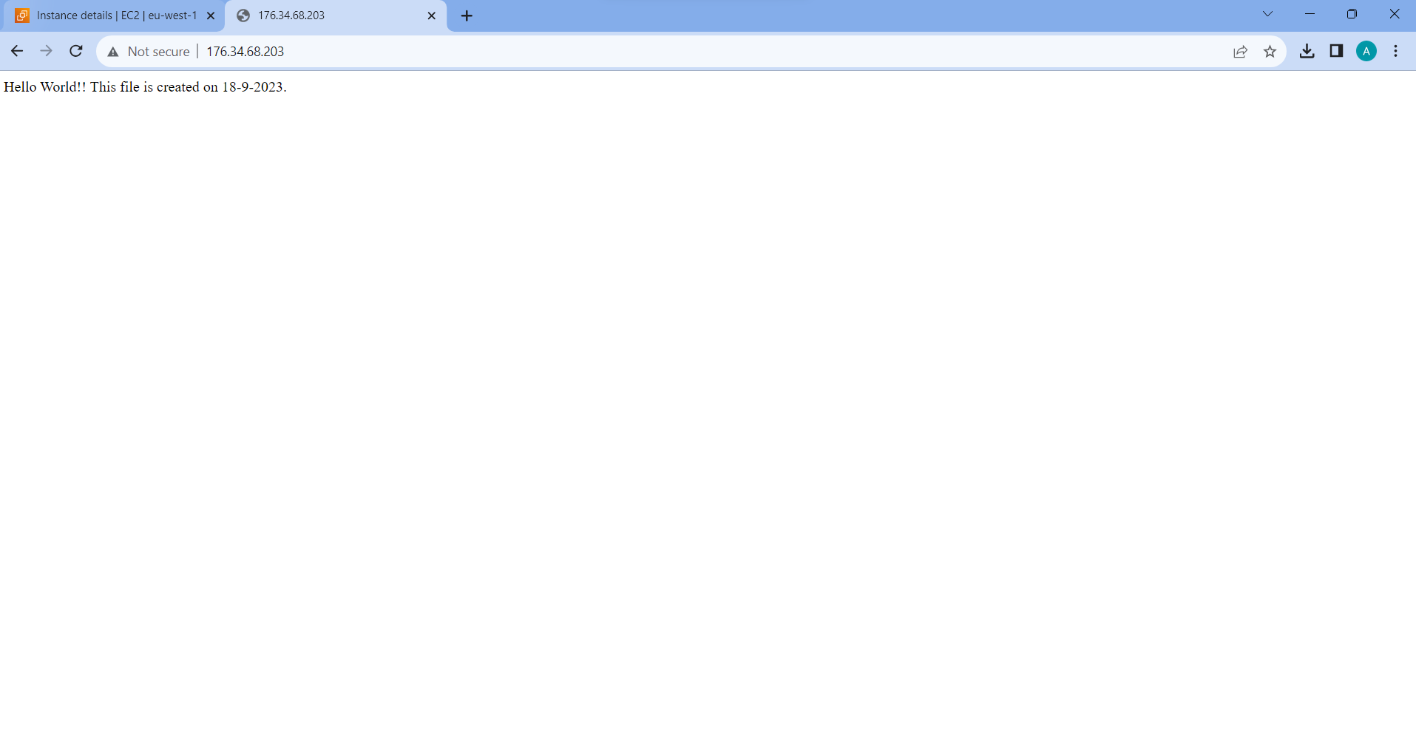

Q2. IAM

Just like ec2 we have to go to the console and search for IAM.

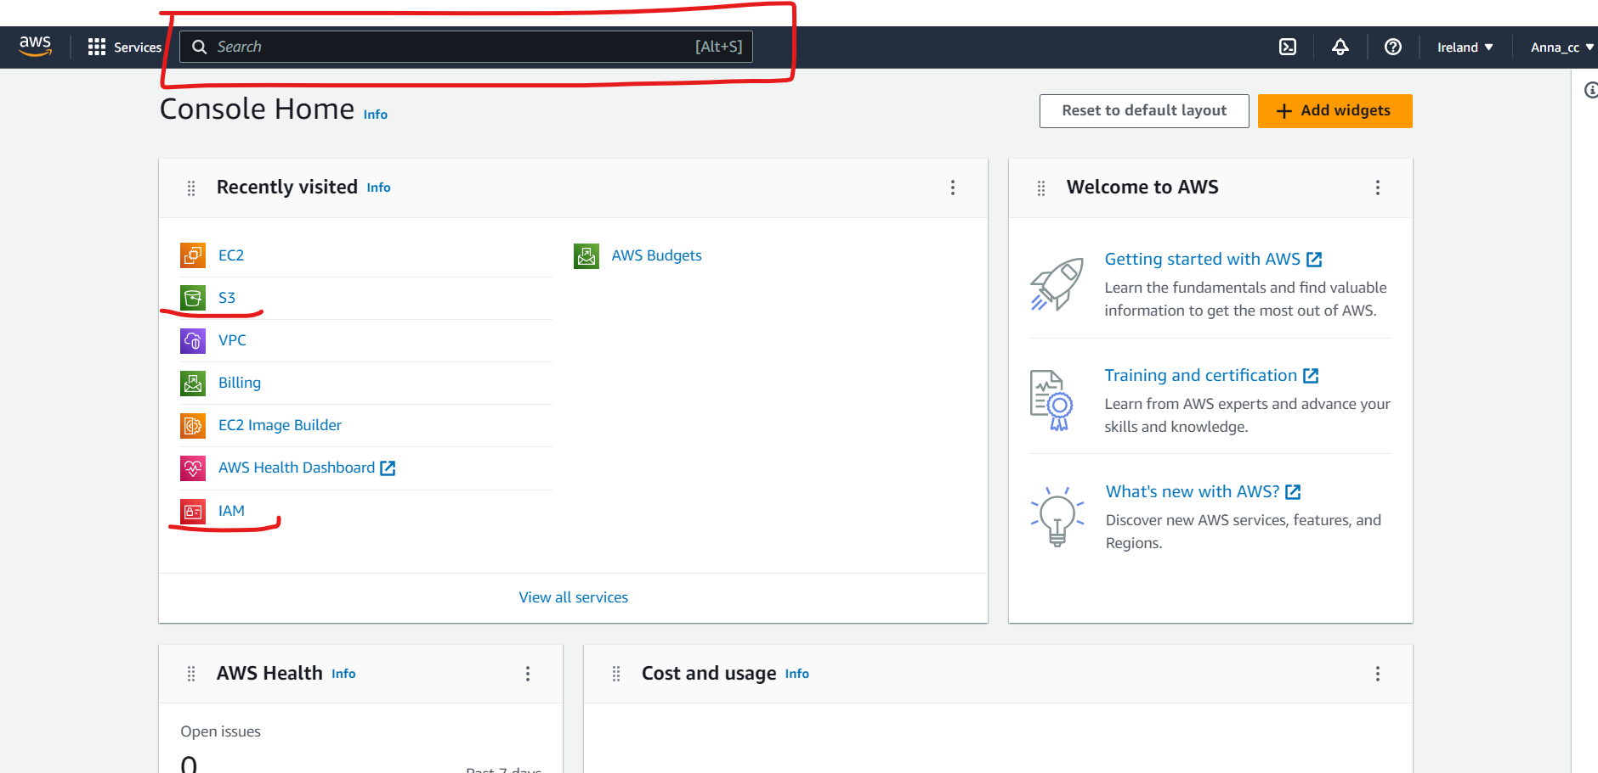

After coming to dashboard we have to click on user.

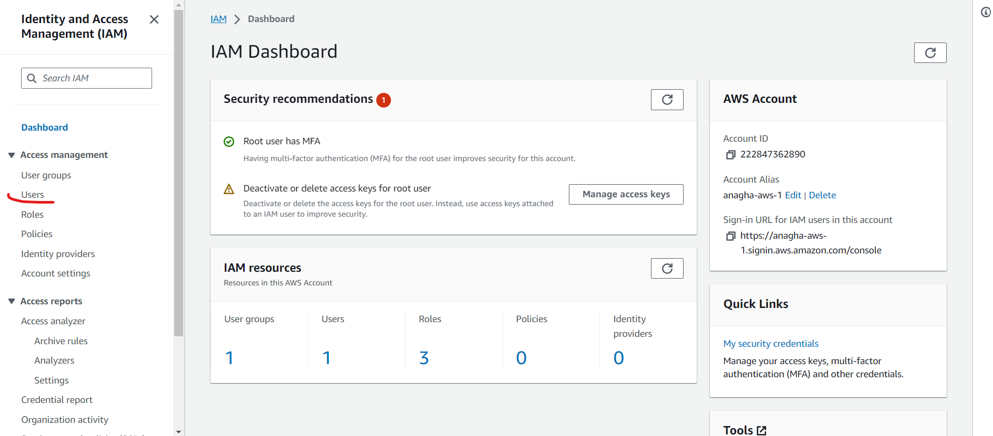

The we have to create a user.

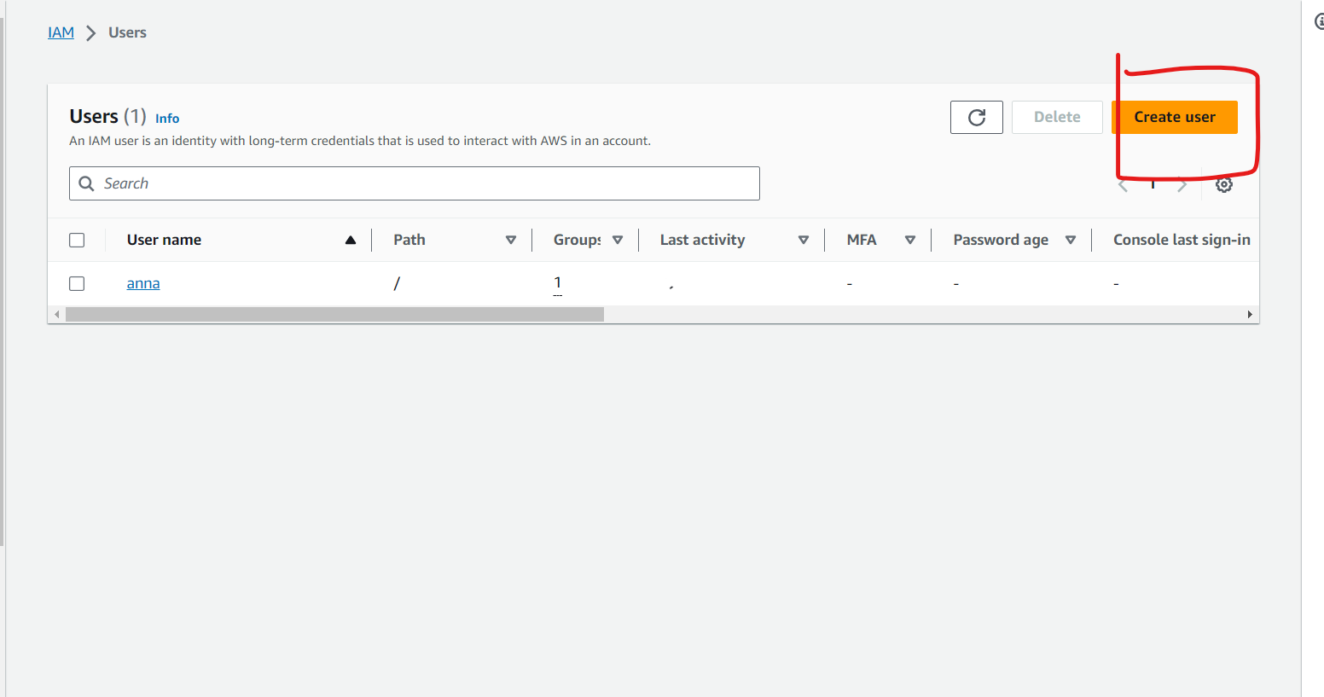

While creating user we have to give the user some policies which the user will work on here we will give the user the read only access to s3 bucket

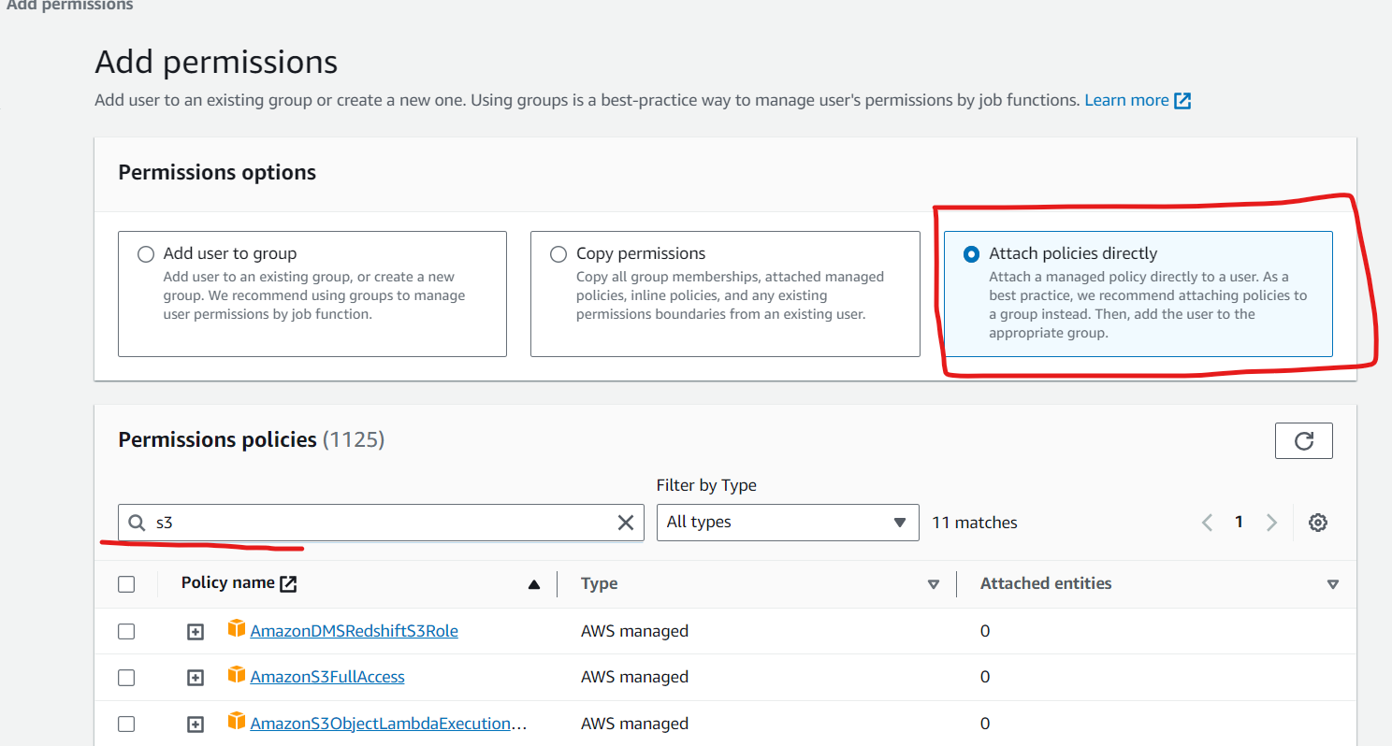

After searching s3 we wll see the list of policies available we have to select read only access/

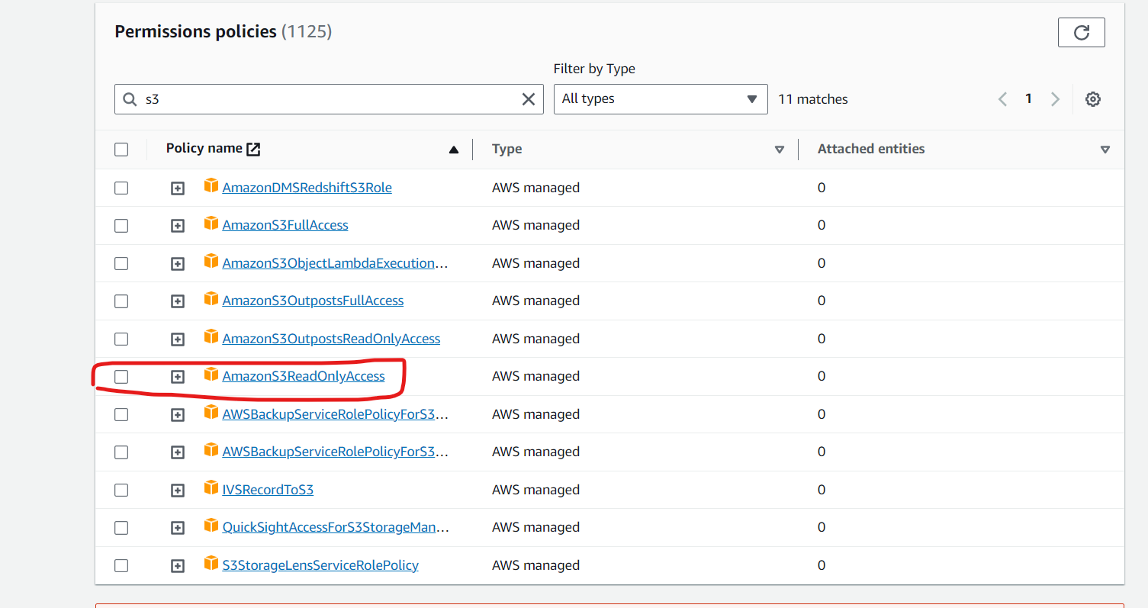

After that we have to review all the info about the permissions we have given to the user and click on create user to complete the process.

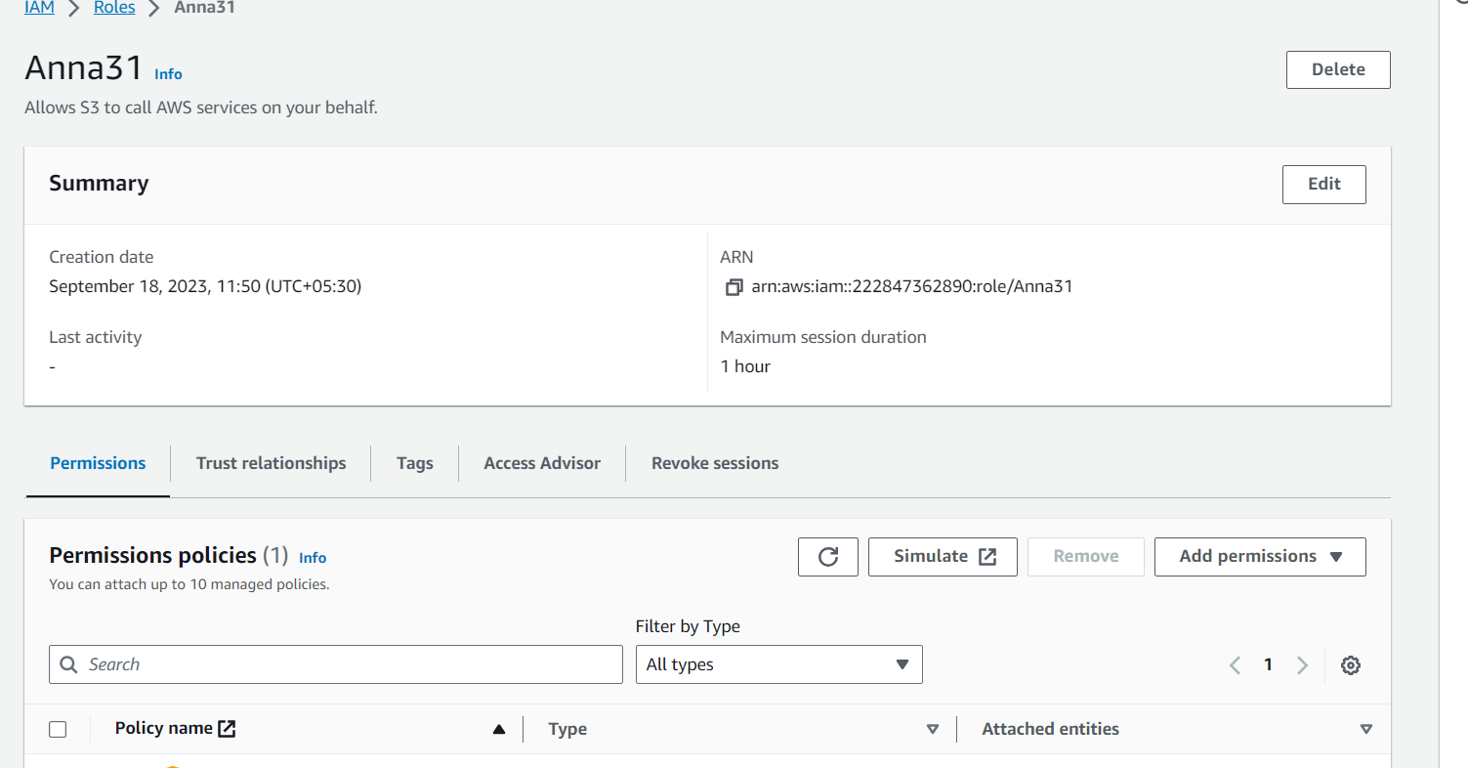

Then we have to click to simulate to go to the page of IAM policy simulator.

There we have to select the user.

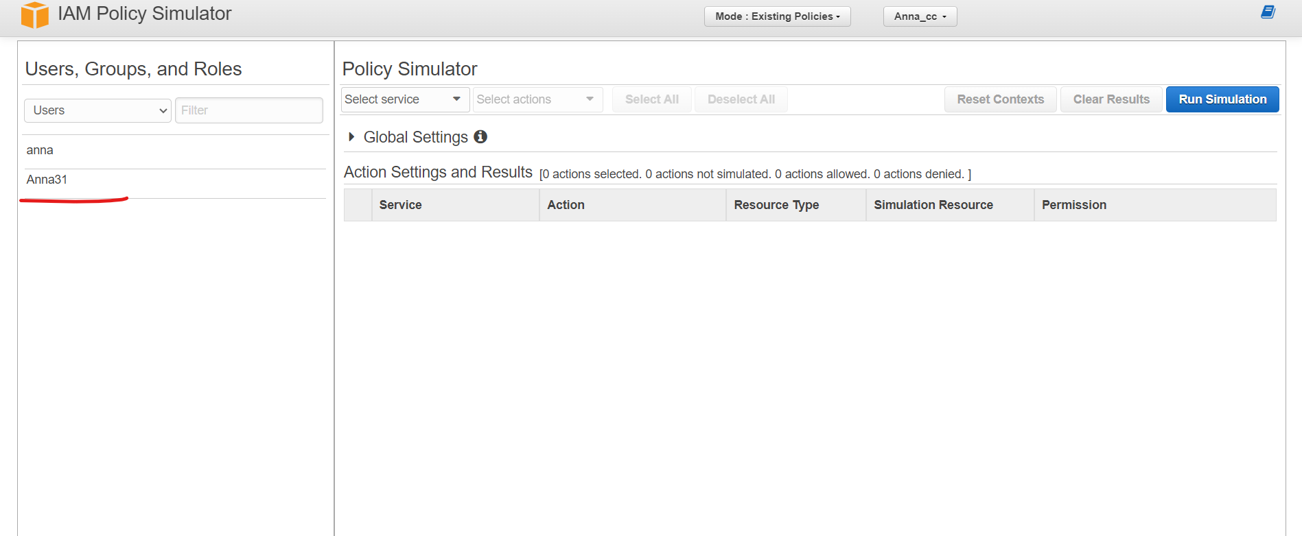

After selecting the user on the right side we have to now select the services as we are checking for s3 I am going to select s3.

Next we have to select the actions we want to user to perform .

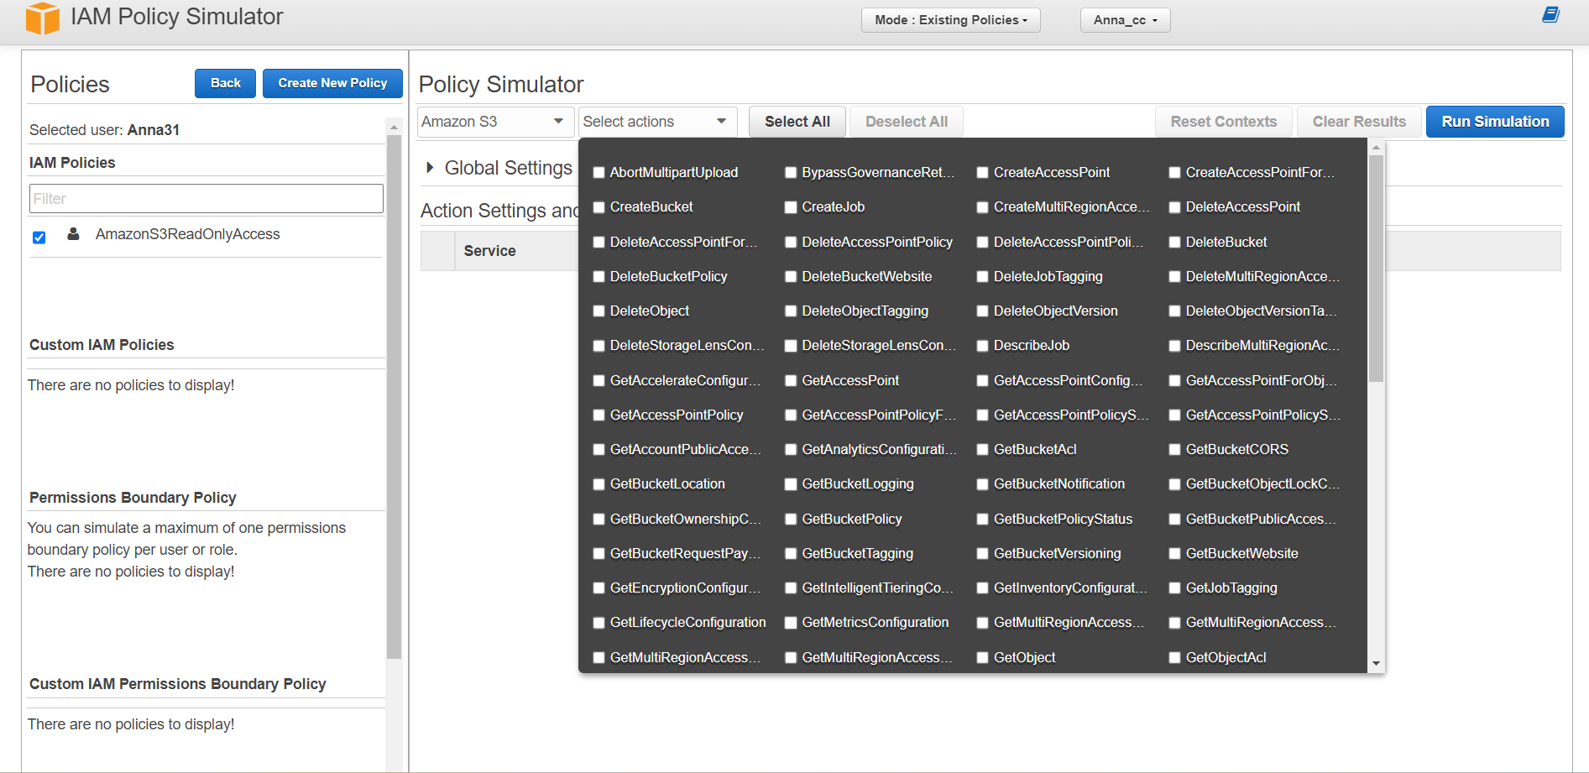

Then we have to click on the run simulation.

After simulating we are getting denied for the permissions , because while creating the user we allowed the user to only have read-only access in the s3 bucket. That is why we are getting denied for the permission.

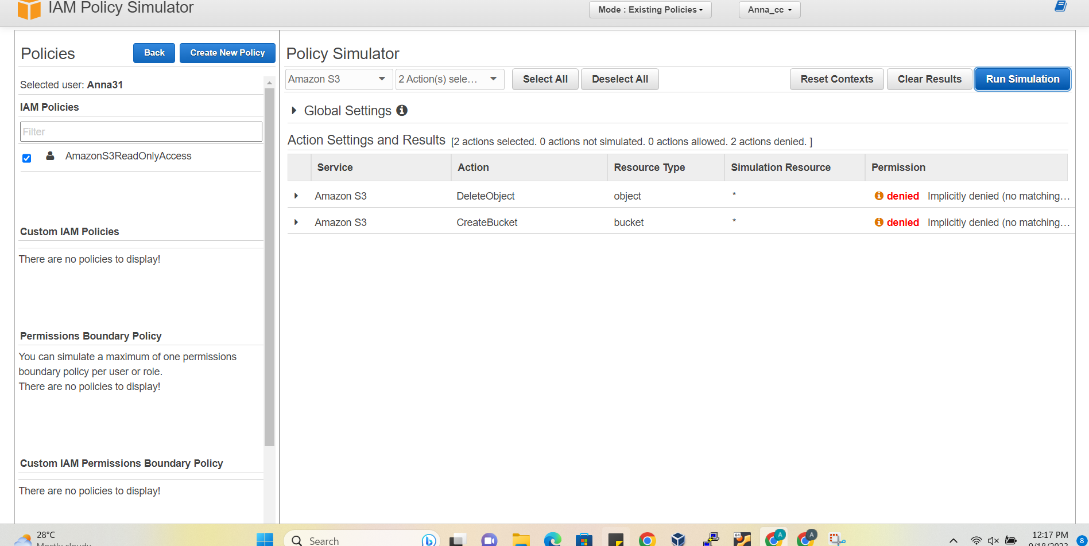

**Linux**

**Q3.**

mkdir dbda

cd dbda

mkdir Sep.txt

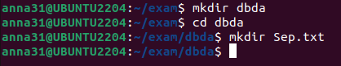

mv Sep.txt batch2.txt

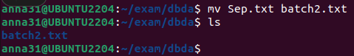

mv batch2.txt dbda_b2

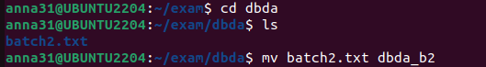



Q1

nano greatest.sh

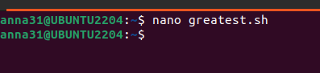

#!bin/bash

echo "Enter the first number : "

read n1

echo "Enter the second number: "

read n2

echo "Enter the third number: "

read n3

if [ n1 > n2 ]

then

